How to Access the Universal Care Plan through the London Care Record (Cerner HIE)
- After you have searched for a patient – a red banner bar is shows if a UCP exists for that patient. | 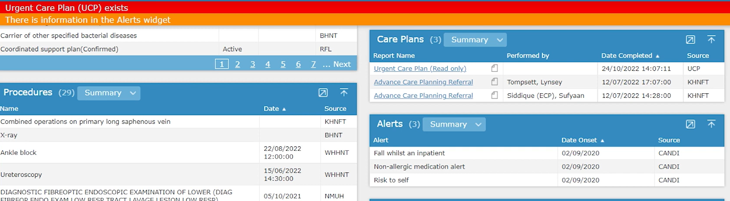
- A Read only option is available in the Care Plan section . | 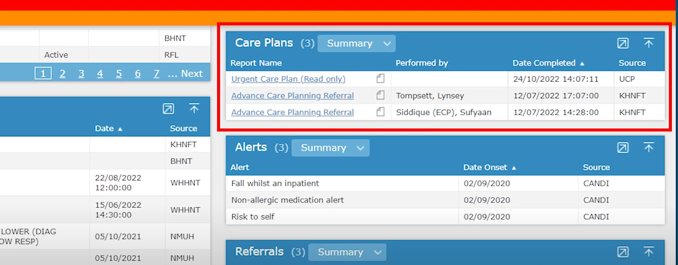
- A create/edit option is available in the Shared Records System section. | 