Accessing the Universal Care Plan through SystmOne and Valida
- Search for the patient in SystmOne using the search tool in the toolbar | 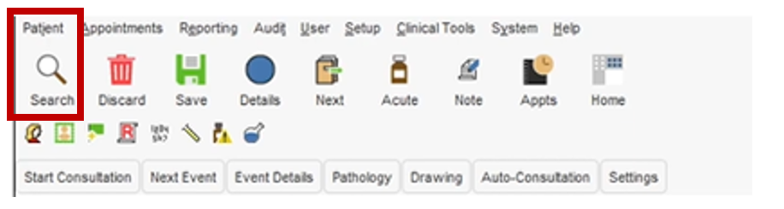
- If the patient has a UCP, Valida will notify you and you can click on the UCP tile | 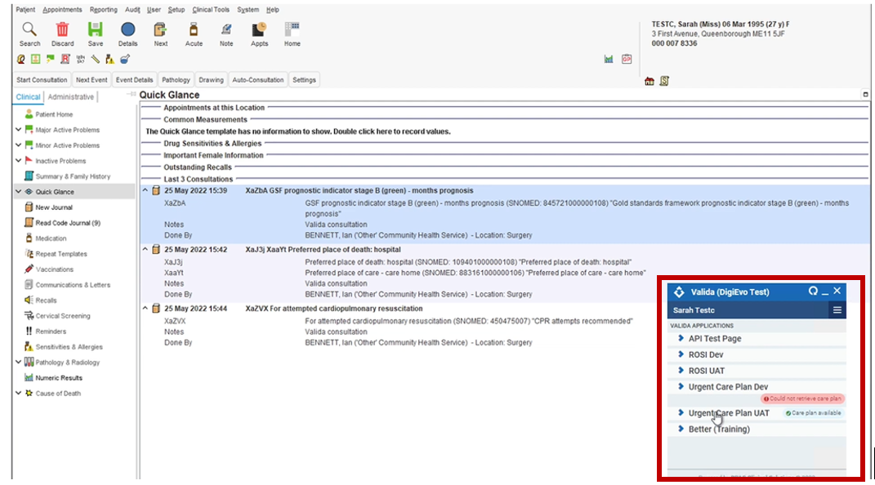
- A summary of the UCP will open on your page | 