How to Access the Universal Care Plan via the UCP Web Portal
- You can apply for UCP Access by submitting the UCP Access Request form found on the UCP Access Page. | 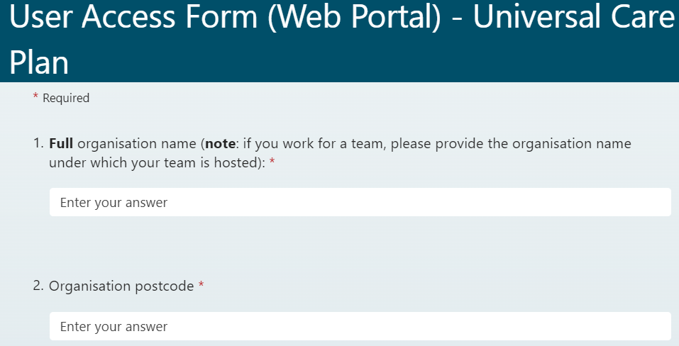
- Once approved, the UCP support team will issue Web Portal credentials to the user.  Users will receive an email from ucp.better@nhs.net with a username and a link to activate their account and set a password. | 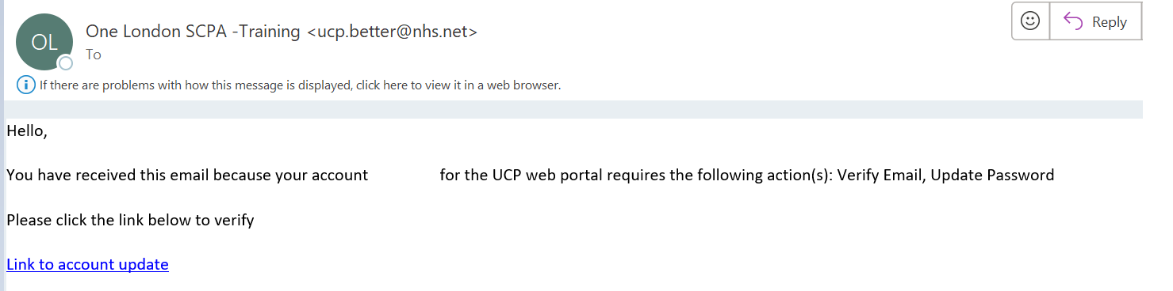
- If your organisation is operating on the Health and Social Care Network, you can access the UCP via this link: https://london-scpa-hscn.better.care/  If you organisation is not operating on the HSCN network you can assess the UCP via this  link: https://london-scpa.better.care/ | 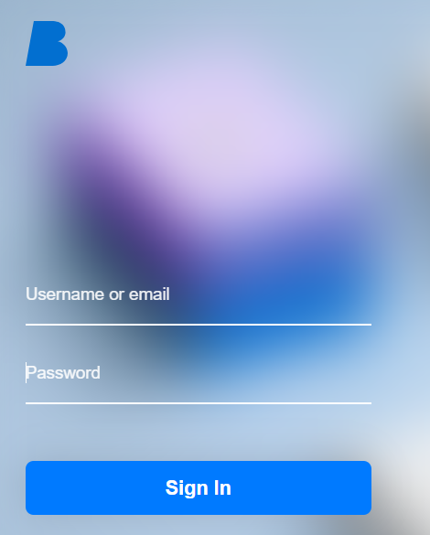
- Search for a patient by any 3 letters of their name or NHS Number | 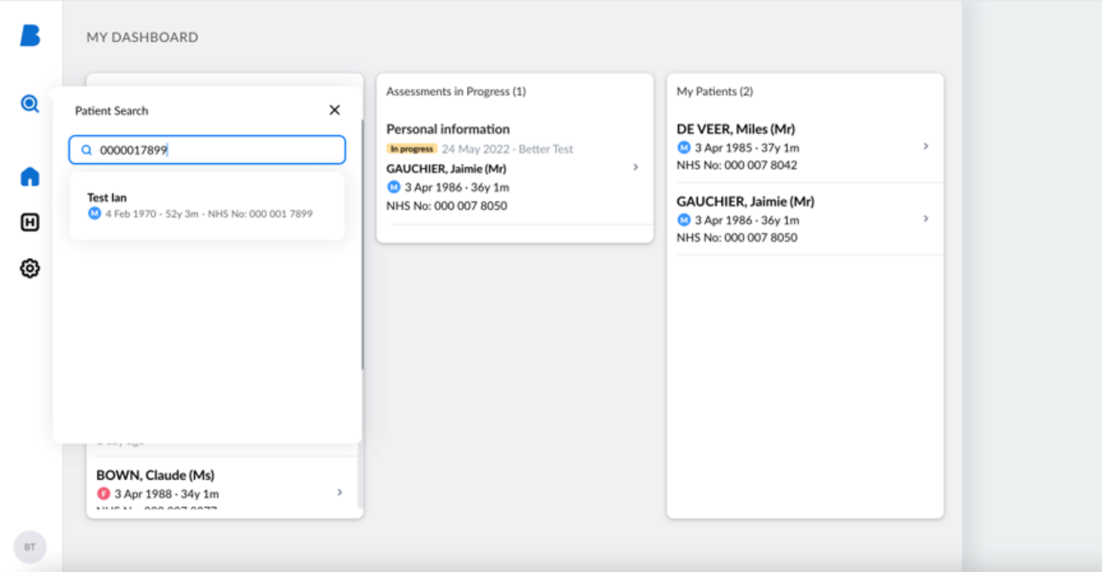
- If you cannot find a patient then click Add New Citizen and enter NHS number and date of birth | 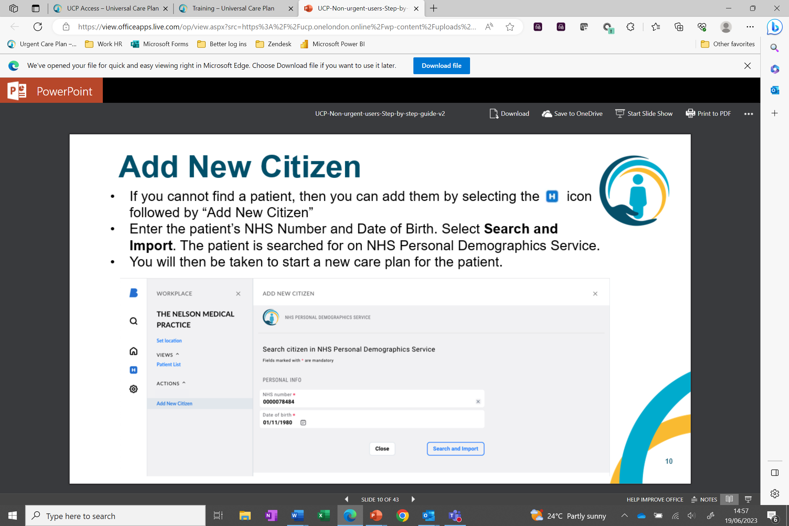
- You are now able to start a UCP Care Plan | 