Accessing the Universal Care Plan through EMIS

- Search for the patient in EMIS using the search functionality. | 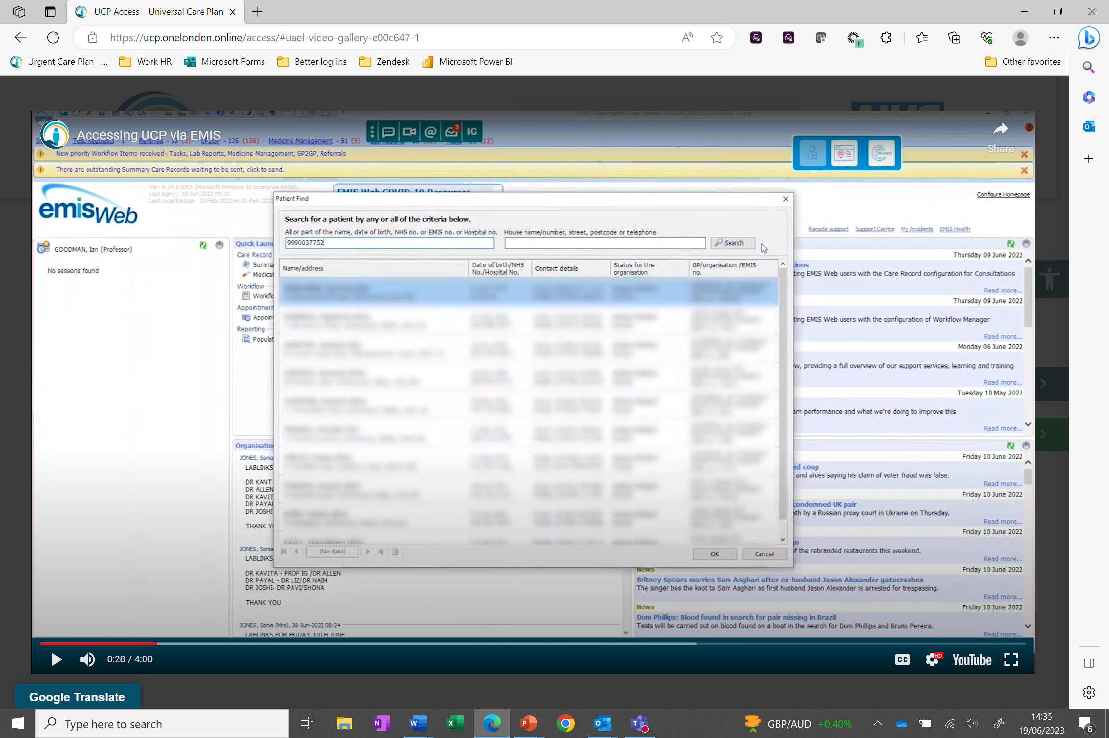
  - If the patient has a UCP, Valida will notify you and you can click on the UCP tile – you may need to open Valida from your desktop: | 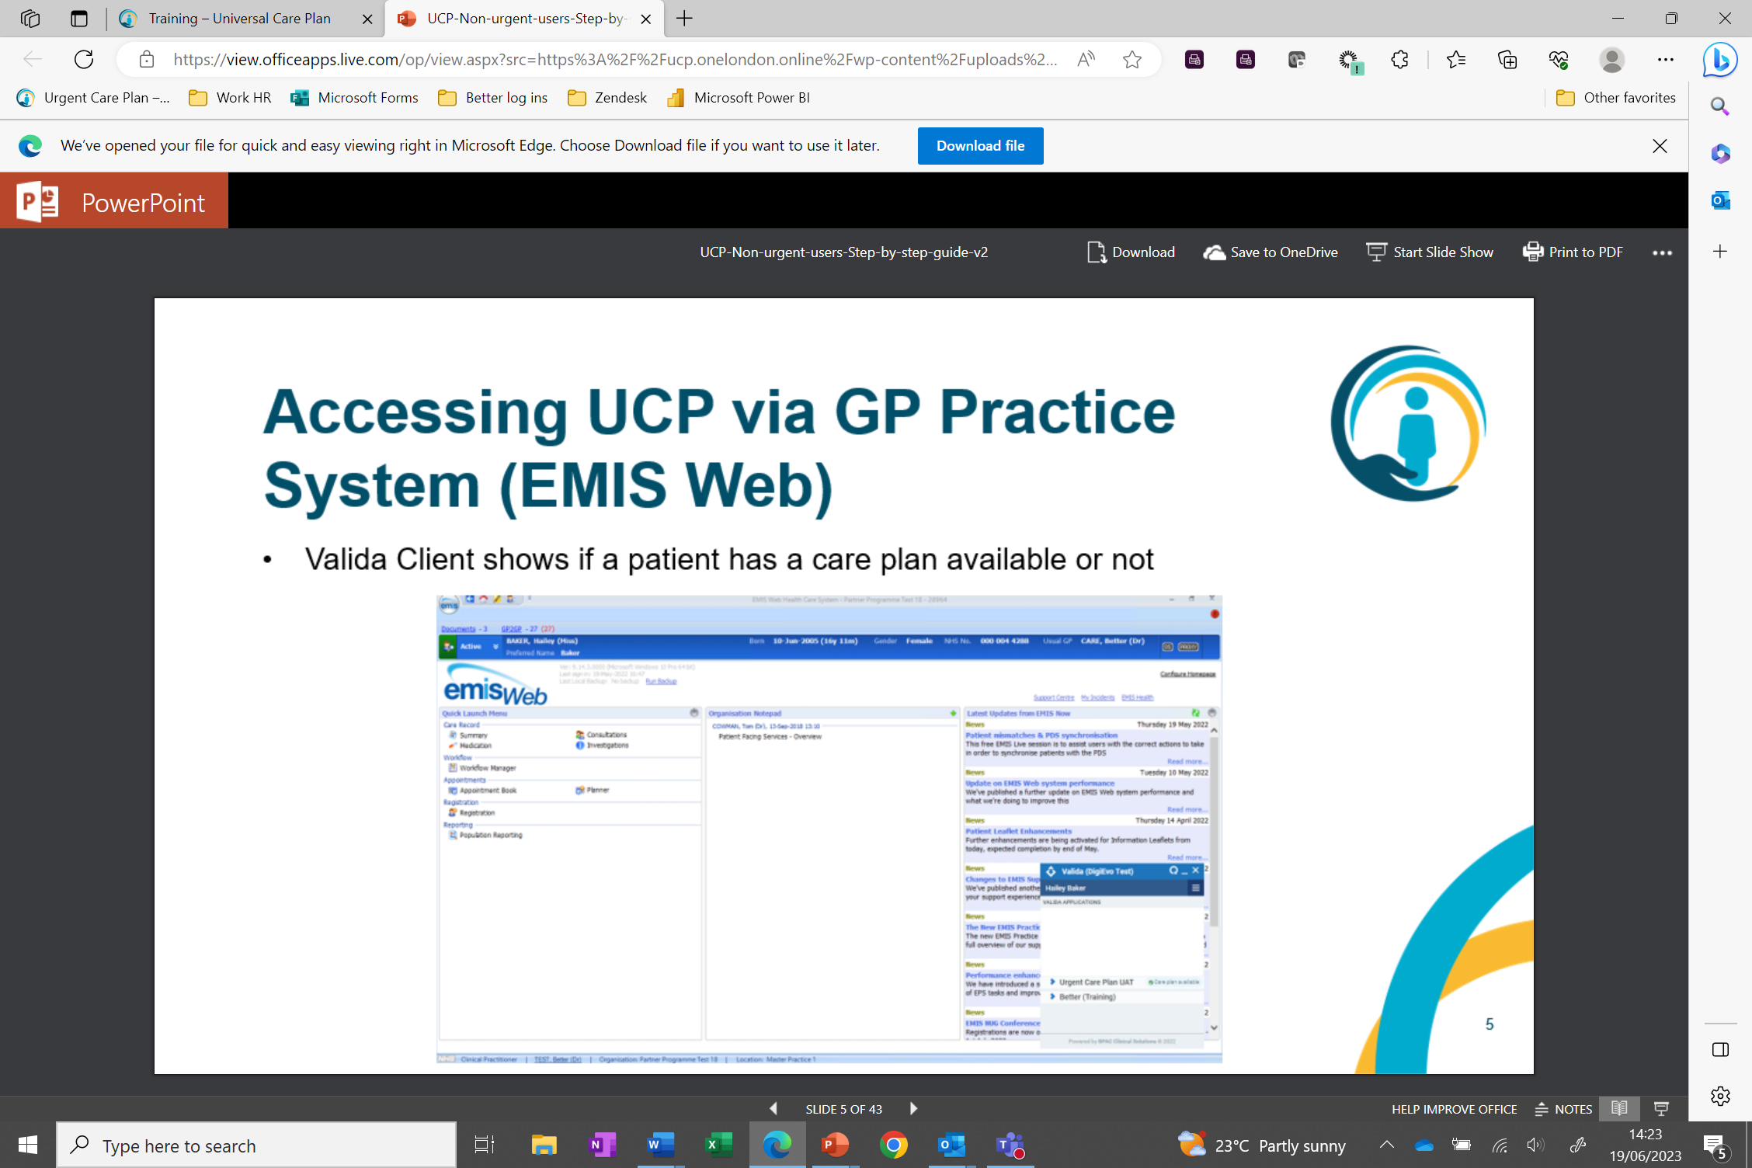  You may be asked to register your smartcard. Click the ‘click here’ link on Valida and follow the instructions. Then move to step 3.
- A summary of the UCP will open on your page | 